Broadcast containment

The ethernet broadcast video

.

Broadcast domains

**When host receives data from broadcast address, it accpets and processes the message as through the message was addressed directly to it**

Switches forward the message to every connected host within the same local network that is the reason why a local area network, is also referred to as a broadcast domain

**If there are too many hosts the traffic can become excessive, and is limited by the capabilities of the switches used to connect them**

To improve performance, it is often necessary to divide local networks into multiple networks or domains

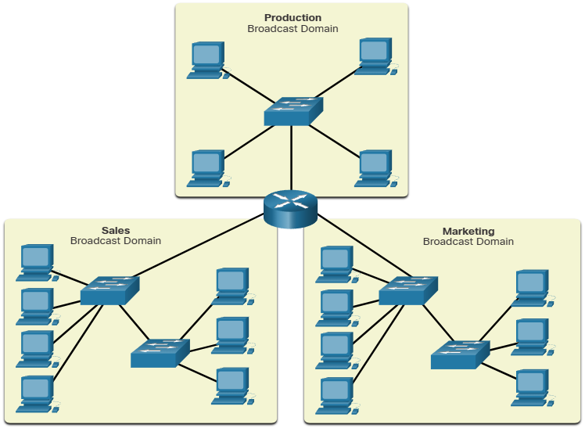

Access layer communication

**On local network, a NIC only accepts a frame if the destination address is either the broadcast MAC address, or else corresponds to the MAC address of the NIC**

Most networks applications, however, rely on the logical destination IP address to identify the location of the servers and clients.

Address resolution protocol video

.

ARP

**It uses a 3 step process to discover and store the MAC address of a host on the local network when the IPv4 address of the host is know:**

1. Sending host creates and sends a frame addressed to a broadcast MAC address contained in the frame is a msg with IPv4 address of the intended destination host
2. Each host on the network receives the broadcast frame and compares the IPv4 address inside the msg with its configured IPv4 address. The host with the matching IPv4 address sends its MAC address back to the original sending host
3. **The sending host receives the msg and stores the MAC address and IPv4 address information in a table called and ARP table**

When the sending host has the MAC address of the destination host in its ARP table, it can send frames directly to the destination without doing an ARP request.

Because ARP msg rely on broadcast frames to deliver the requests, all hosts in the local IPv4 network must be in the same broadcast domain

